**Project Name**

ECEN 106 – Computer Systems Final Project

Brigham Chen

3/30 2022

**What it does and how it works**

I use the Ultrasonic Sensor to detect the distance. If we are at a particular distance, the fan will be turned on.

**Hardware: wiring diagram and photos**

**This is the circuit I made.**

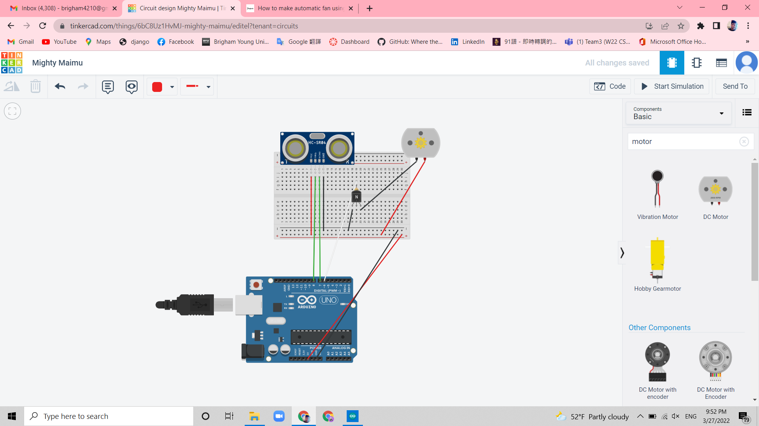

This is the picture I took for the project I made.

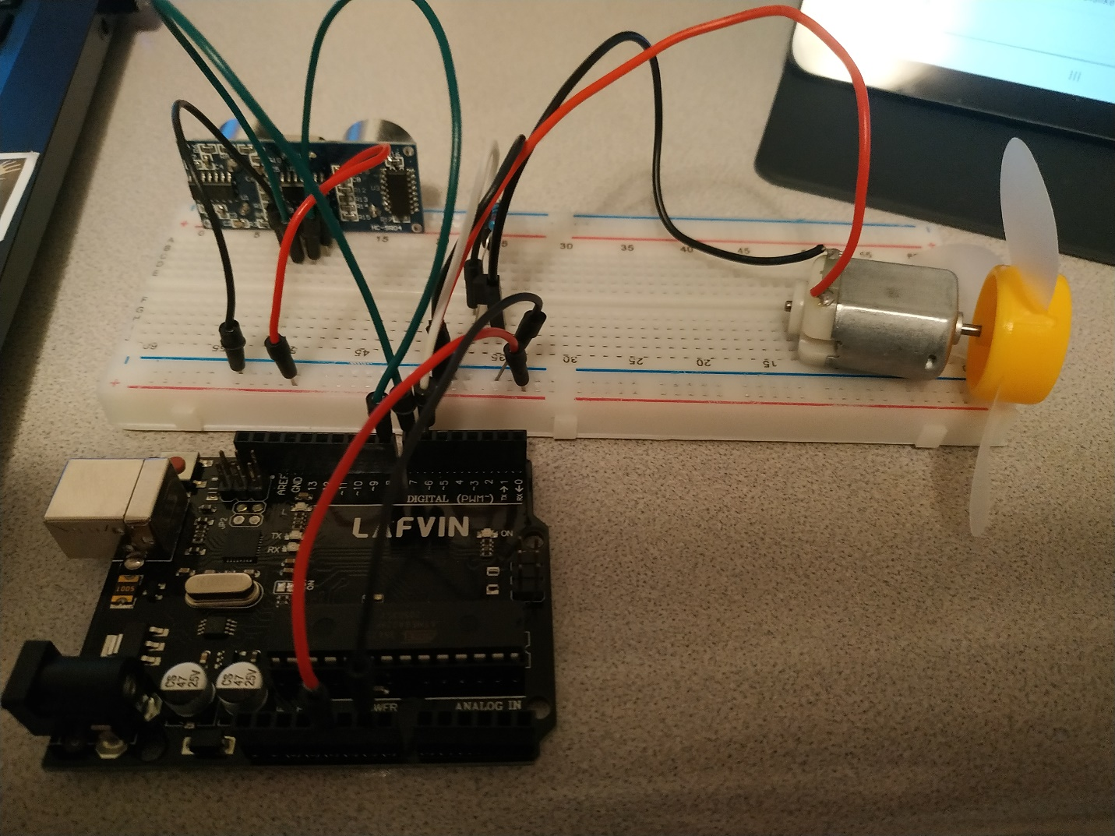

**Software: Arduino sketch:**

<https://simpletechproject.wordpress.com/2018/10/12/how-to-make-automatic-fan-using-arduino-and-ultrasonic-sensor/>

this link is where I get the code.

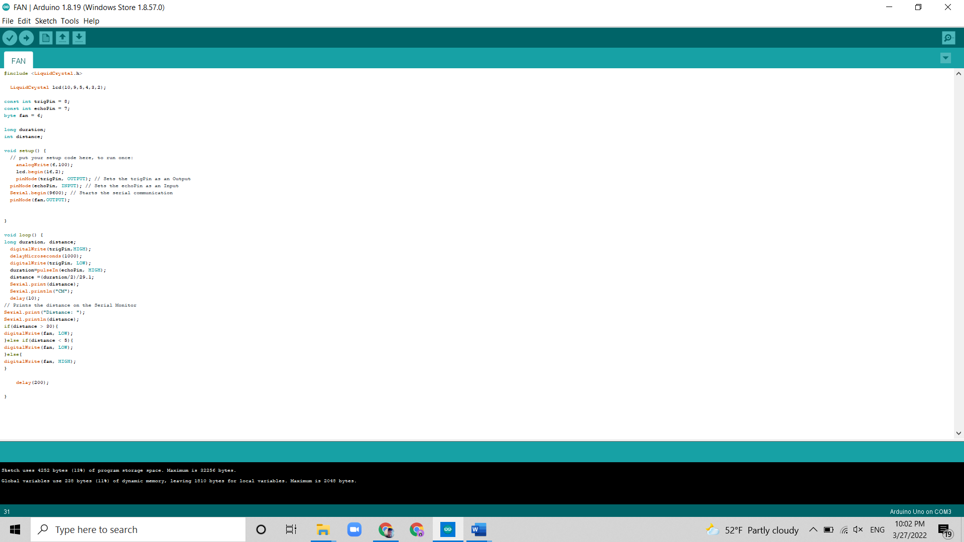

This picture shows the code I alternated.

This is the link to the code.

https://github.com/brigham4210/Fan_Arduino/blob/main/FAN/FAN.ino

This is the link to the video for the project.

https://youtu.be/_n5VCsy-PEM